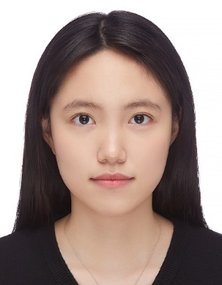

**Gyubin Park**

Dept of IT Convergence and Application Engineering

Pukyong National University

4-Engineering Building AI .LAB 314 / 365, Sinseon-ro, Nam-gu, Busan, Republic of Korea

[lizpark@gmail.com](mailto:lizpark@gmail.com)

Cell Phone : +82-010-2808-5701

# Personal Data

* Birth: 1998/08/11 in Republic of Korea
* Github : <https://github.com/deschanel11>
* Language: First language Korean, Fluent in English
* “Never give up.”

# Education

Mar. 2017 ~ **Pukyong National University** Busan, Korea

Present Bachelor of IT Convergence and Application Engineering

*Cumulative GPA 3.74/4.5*

Mar. 2019 ~ **Bangor University** Wales, United Kingdom

Aug. 2019International Student Program, School of Computer Science

Mar. 2014 ~ **Sam-Hyeon Girl’s High School** Jinju, Korea

Feb. 2017

# Research Interest

* **Computer Vision, Image processing, Machine Learning**
* Researching Image to Music Algorithm (Sensory replacement project) with ETRI

# Work Experiences

* **Undergraduate researcher** at *AI Lab, Pukyong National University*Sep. 2021 ~ Present
* Research Image to Music Algorithm (Sensory replacement project) with ETRI
* **Intern** at *Ctrl Lab at KAIST* Jul. 2021 ~ Aug. 2021
* Studied Image Classification Networks and Object Detection with YOLO Algorithm

# Project Experiences

* **Dementia Pre-checking Application with Teachable Machine**
* <https://github.com/Soo-ss/capdi.git>
* **Image to Music Algorithm Research with ETRI**

# Skills and qualfications

* **Python, Pytorch, C/C++ Programming**

Last modified: September 09, 2021